Title: , Autonomous Helicopter Navigation System, System Level, Platform Electronics Enclosure Design Document

*“A Project”*

Prepared by Date _______________

,

Checked by Date _______________

Michael Kincel,

Approved by Date _______________

, Student Manager 2010

Authorised for use by Date _______________

Dr Luis Mejias, Project Coordinator

**QUT Avionics**

Queensland University of Technology

CRCSS-EESE, GPO Box 2434

Gardens Point Campus

Brisbane, Australia, 4001.

Telephone (+61 7) 3864 1772

Facsimile (+61 7) 3864 1517

e-mail luis.mejias@qut.edu.au

web <http://code.google.com/p/ahns10/>

This document is Copyright 2010 by the QUT. The content of this document, except that information which is in the public domain, is the proprietary property of the QUT and shall not be disclosed or reproduced in part or in whole other than for the purpose for which it has been prepared without the express permission of the QUT

**Revision Record**

|  |  |  |  |
| --- | --- | --- | --- |
| Document Issue/Revision Status | **Description of Change** | **Date** | **Approved** |
|  | Initial Issue |  |  |

**Distribution List**

|  |  |  |  |
| --- | --- | --- | --- |
| **Name** | **Affiliation** | **Distribution Date** | **Approved** |
| Avionics Lab File Archive | QUT Avionics |  |  |

**Foreword**

This document outlines the design chosen to mount on-board hardware for the 2010 autonomous helicopter navigation system 2010 to the platform. The initial design incorporated two levels of platters, which held the assortment of payload, but throughout testing it was found that the low centre of gravity negatively affected flying conditions. A second design was implemented which removed the bottom tier, and moved the battery to on top of the main airframe. This improved both flying conditions but reduced the overall weight of the payload, which inturn increases flight time. This design was used in the final product to house the hardware, and also offers protection against impacts during flight incidents.

**Table of Contents**

Paragraph Page No.

1 Introduction 8

1.1 Scope 8

1.2 Background 8

2 Reference Documents 9

2.1 QUT Avionics Documents 9

2.2 Non-QUT Documents 9

3 High Level Objectives, System Requirements and Acceptance Testing 10

4 Design 12

4.1 Objectives of Design 12

4.2 Payload Information 12

4.3 Design Outline 13

4.3.1 Initial Design 14

4.3.2 Final Design 16

5 Implementation 18

5.1 Initial Design Implementation 18

5.2 Final Design Implementation 18

6 Conclusions 20

7 Recommendations 21

**List of Figures**

Figure Page No.

Figure 1 – Illustration of Initial Design (Cinema 4D) 14

Figure 2 – Acrylic Cutter Initial Design in CorelDRAW v14.0 15

Figure 3 – Illustration of Final Design (Cinema 4D) 16

Figure 4 – Acrylic Cutter Final Design in CorelDRAW v14.0 17

Figure 5 – Platform with Initial Electronics Mounting System 18

Figure 6 – Final Design of Mounting System 19

Figure 7 – Battery Mounting for Final Design 19

**List of Tables**

Table Page No.

Table 1 – Mounting System Requirements 10

Table 2 - Mounting System Requirement Acceptance Tests 10

Table 3 - Payload Information 13

**Definitions**

|  |  |
| --- | --- |
| AHNS | Autonomous Helicopter Navigation System |
| QUT | Queensland University of Technology |
| CoM | Centre of Mass |
| IMU | Inertial Measurement Unit |
| HLO | High Level Objective |
|  |  |
|  |  |
|  |  |
|  |  |
|  |  |
|  |  |
|  |  |
|  |  |

# Introduction

The Autonomous Helicopter Navigation System (AHNS) platform required modifications to allow the electronic payload to be mounted for flight operations. The design required the main electronics board, battery, camera and ultrasonic sensor to be mounted with the intention of keeping the CoM of the platform aligned with the engines. The electronics mounting was also required to provide protection to all the expensive equipment on the platform, while ensuring that they could independently preform their desired tasks.

## Scope

The scope of this document is limited to the design and implementation of the mounting system on the AHNS platform, and although references dimensions of electronics, does not mention the wiring or board design used.

## Background

Autonomous Helicopter Navigation System 2010 has introduced quad-copter helicopters for the first time, with single rotor helicopters being used in previous years. Previous designs have been developed for the use on single rotor blade helicopters, and as such, is not reusable. The addition of on-board computer module, camera, IMU, and ultrasonic sensor has also facilitated much more area needed for mounting.

# Reference Documents

## QUT Avionics Documents

|  |  |  |
| --- | --- | --- |
| RD/1 | AHNS-2010-SY-HL-001 | AHNS, High Level Objectives of |
| RD/2 | AHNS-2010-SY-SR-001 | AHNS, System Requirements of |

## Non-QUT Documents

|  |  |  |
| --- | --- | --- |
| RD/3 | http://au.farnell.com/ettinger/05-13-451/spacer-m3x45-vzk/dp/1466727 | SPACER, M3X45-VZK |

In the event of any conflict between this document and any RD referenced herein, such conflict shall be notified to Dr Luis Mejias.

In the following text, RD/x identifies referenced documents, where "x" denotes the actual document.

# High Level Objectives, System Requirements and Acceptance Testing

[HLO-1] Platform from [RD/1] established that a platform should be developed and maintained to facilitate flight and on board hardware integration. This high level objective encompasses the design of the electronic mounting system.

The electronics mounting sub-system has two system requirements associated with its design, one baseline and one derived outlined in Table 1. Baseline requirements were specified by the customer and from previous AHNS experience whilst derived requirements were developed after a period of preliminary systems design.

Table – Mounting System Requirements

|  |  |  |
| --- | --- | --- |
| **Requirement** | **Definition** | **Test Report** |
| SR-B-01 | The platform shall have the ability to be manually manoeuvred with a radio controller. | AT-01 |
| SR-D-01 | The platform shall be capable of maintaining controlled flight with a total payload of 400 grams. | AT-11 |

The system requirements outline that the platform must be able to operate in flight conditions with a payload of 400 grams. The acceptance tests are listed in the table of system requirements and described in [RD/2] and Table 2. This therefore requires the electronics mounting to be rigid to allow sudden attitude and position changes, and strong enough to hold 400 grams of payload equipment.

Table - Mounting System Requirement Acceptance Tests

|  |  |  |
| --- | --- | --- |
| **Test Report** | **Test Type** | **Testing Procedure** |
| AT-01 | Inspection | The airframe platform will be tested in radio controlled mode. All basic and advance manoeuvres will be tested to ensure that full control is achieved. |
| AT-11 | Inspection | The platform will have 400 grams of weight attached, while keeping the CoG in the centre of the airframe, and tested to see if it can lift off the ground. All basic and advance manoeuvres will be tested to ensure that full control is achieved. |

# Design

The electronics mounting system for AHNS 2010 underwent several design changes throughout the year due to many factors, such as different payloads being used, the centre of gravity position changing and improvements to design to prevent damage received from crashes. The following section outlines the design choices throughout the semester, and outlines all designs implemented.

## Objectives of Design

There were several objectives for the design of the mounting system that were not outlined in the system requirements. These requirements were put in place to mitigate schedule and finical risk present after serious crashes in flight-testing. The following list outlines the informal requirements for the electronics mounting system.

* The design will protect the electronic equipment from striking the ground or other parts of the airframe in the event of a crash.
* The frame that supports the equipment will be made of a material that will snap under a large instant force, such as a crash, to prevent this shock damaging the main electronics board or airframe.
* The mounting system will be easy and cheap to manufacture, and within a local area to reduce delivery time.
* Vibration dampening will be applied to all electronics boards to ensure data collected is not corrupted with noise.
* Allow easy access to electronics and line of sight to all LED’s.
* Ensure ventilation for electrical components is available.

These informal requirements will be factored into all design choices of the electronics mounting system.

## Payload Information

The dimensions of each electronic payload device are different, and each will require different mounting positions within the platform. Table 3 outlines the dimensions and comments on each component that requires mounting to the platform.

Table - Payload Information

|  |  |  |
| --- | --- | --- |
| **Payload Item** | **Dimensions (L, W, H) / Weight** | **Comments** |
| Main Board | (103.1, 83.0, 42.0) mm  / 180 grams | The board have varying height, with the highest point at 42 mm. The board must be mounted upright, on vibration dampeners. |
| Battery | (107.5, 35.0, 30.0) mm  / 130 grams | The battery is the heaviest component, with deans and charger cable protruding out one end. |
| Switch | (30.0, 15.0, 60.0) mm  / 20 grams | The switch requires a 12 x 12 mm circle hole for mounting, and a lot of area underneath for hanging cables. |
| Ultrasonic Sensor | (22.9, 22.0, 35.0) mm  / 70 grams | Ultrasonic must be mounted upside down with clear line of sight to ground from platform. A 17.5 x 17.5 mm hole must be cut for sensor to fit through. |
| Camera | (102.5, 53.5, 55.0) mm  / 130 grams | Camera requires 20 x 20 mm hole for the lens to see through, and mounted with vibration dampeners. |
| Antenna 1 | (7.0 x 7.0) mm [hole dimension] | The camera antenna needs to be mounted to the airframe through a slot with locking nut. |
| Antenna 2 | (12.3 x 12.3) mm [hole dimension] | Gumstix Overo antenna needs to be mounted to the airframe through a slot and clip. |

The total weight for all components within the payload, as outlined in Table 3, is approximately 400 grams (no including battery). Therefore the mounting system must be able to support that load under flight conditions.

## Design Outline

To satisfy the design objectives outlined in section 4.1, it was decided to utilise a tier design, which consist of several levels of mounting platforms. This will allow easy access, line of sight to the electrical components, and ventilation to cool heat sinks of the payloads. Metal spacers were used to separate the tiers, which provide a very strong structure to house the payload.

QUT J-Block workshop houses an acrylic plastic sheet-cutting machine, which allows computer-designed drawings to be formed automatically. It was decided that this fulfilled all of the requirements, with the material breaking under a desired load. The cutting facility and materials is free to use, and new plates can be acquired in less than an hour.

Industry vibration dampeners were bought with the airframe, and will be used to reduce noise on the main circuit board and camera model.

### Initial Design

The initial design incorporated all payload items outlined in Table 3, which are positioned on a two tier mounting system between the landing gear of the platform. It was decided that the IMU needed to be located as close to the CoM of the platform, so that the acceleration values were as accurate as possible. Therefore the main electronics board, which houses the IMU, was to be mounted on the top tier just underneath the CoM.

The top tier consisted of the main power switch, main electronics board, and both antennas. The bottom tier housed the camera, battery and ultrasonic switch facing downwards. An initial concept design was developed in a 3D animation program called Cinema 4D, and a render is shown in Figure 1.

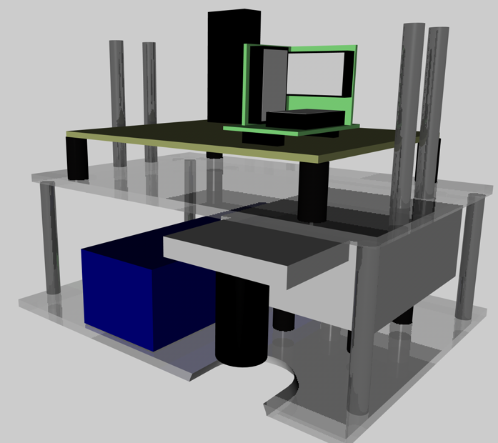

Figure – Illustration of Initial Design (Cinema 4D)

The acrylic cutting machine used Corel Draw version 14.0 files to determine the paths that the cutter used. The program was acquired and the two tier platters were designed to allow mounting locations, payload placing indications and viewing holes. Figure 2 is an illustration taken from the CorelDRAW file, with the first image being the top tier, and the bottom being the lower tier. The program cuts through the plastic on red lines, and engraves blue lines on one side of the acrylic sheet.

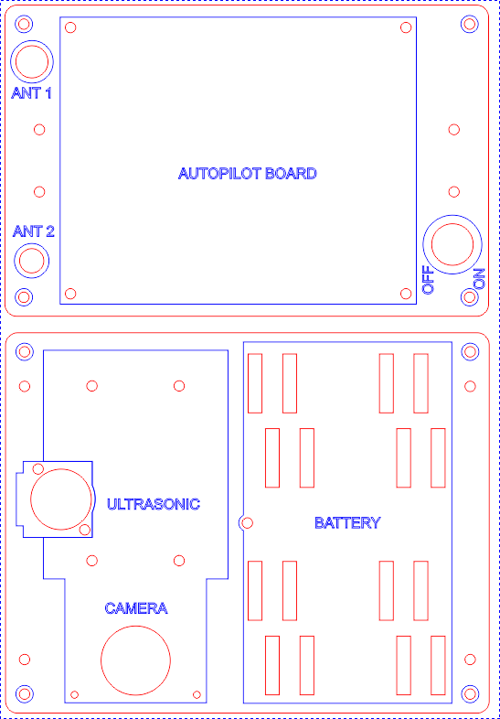

Figure – Acrylic Cutter Initial Design in CorelDRAW v14.0

The top tier is connected to the bottom tier by four 40 mm metal spacers, while the top tier connects to the pre-drilled holes of the lander gear with four 45 mm metal spacers. The battery had several mounting locations to shift the CoM to the desired location.

### Final Design

During the semester the localisation technique for the platform changed, which no longer required the camera to be mounted to the system. This forced changes in the hardware mounting for several reasons. Due to the camera being removed, the CoM could no longer be set to the desired location without adding weights. During initial flight tests it would found with the battery so low, it made the helicopter sluggish to control. Also it was found that in the event of a sudden drop the undercarriage would always hit the ground due to the 2nd tier being to low to the ground. This therefore prompted the bottom tier to be removed with the camera, battery repositioned on top of the platform, and the ultrasonic sensor mounted onto the top tier. An initial concept design was developed in a 3D animation program called Cinema 4D, and a render is shown in Figure 3.

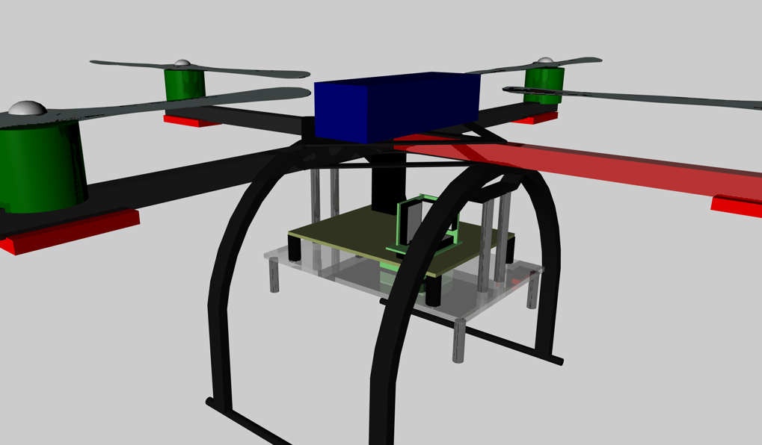

Figure – Illustration of Final Design (Cinema 4D)

The one tier mounting system looks similar to the previous design but the ultrasonic system has been added underneath the autopilot board. Also due to the large length of the cables running under the power switch, it was mounted ninety degrees along the bottom of the tier. The bottom piece of Figure 4 was bent at 90 degrees in the middle and attached to the tier.

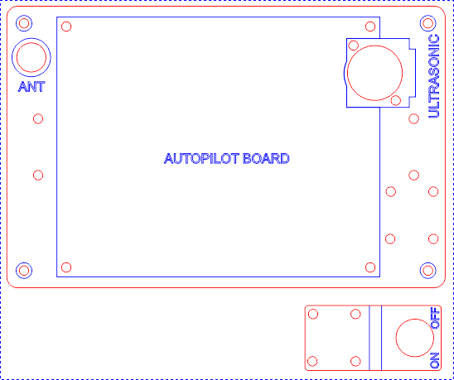

Figure – Acrylic Cutter Final Design in CorelDRAW v14.0

Similar to the initial design, four 45 mm metal spacers were used to attach the tier to the airframe landing gear, and Velcro straps were used to attach the battery.

# Implementation

## Initial Design Implementation

The design mentioned in section 4.3.1 was created at the acrylic plastic sheet-cutting machine, and attached to the airframe with 40 and 45 mm M3 spacers outlined in RD/3. Figure 5 shows the initial design for the mounting system attached. Underneath the bottom platter soft shock absorbers where placed to reduced damage if the platter hit the ground.

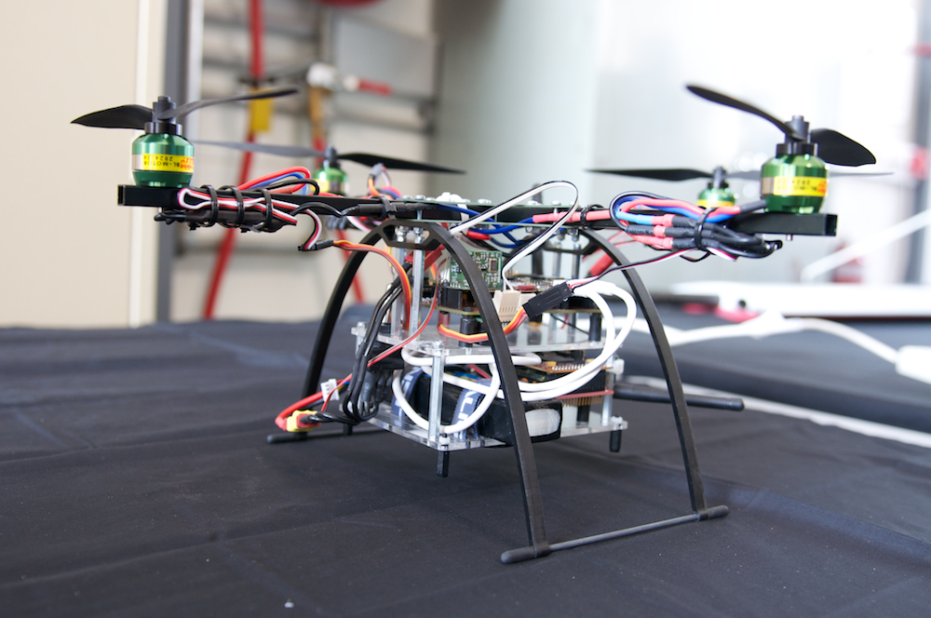

Figure – Platform with Initial Electronics Mounting System

It can be seen in Figure 5 that with the payload attached the bottom tier is very close to the ground, which caused problems in flight-testing when the helicopter was dropped more that thirty centimetres off the ground. Also with the weight of the battery and camera so low with respect to the CoM of the platform, the helicopter was sluggish and hard to control. Also after the camera was no longer required on the platform, it because to difficult to shit the CoM into the desired position. It therefore was required to re-design the mounting system to take account for these developments.

## Final Design Implementation

The final design removed the bottom tier, and moved the battery to the top frame, which in turn moved the CoM to a more appropriate position. Figure 6 shows the final mounting design attached to the landing gear with spacers. The main electronics board is mounted with vibration dampeners, with enough clearance from the airframe above. Also the figure illustrates the mounting system from the communications antenna, which is clipped into the pre-cut hole.

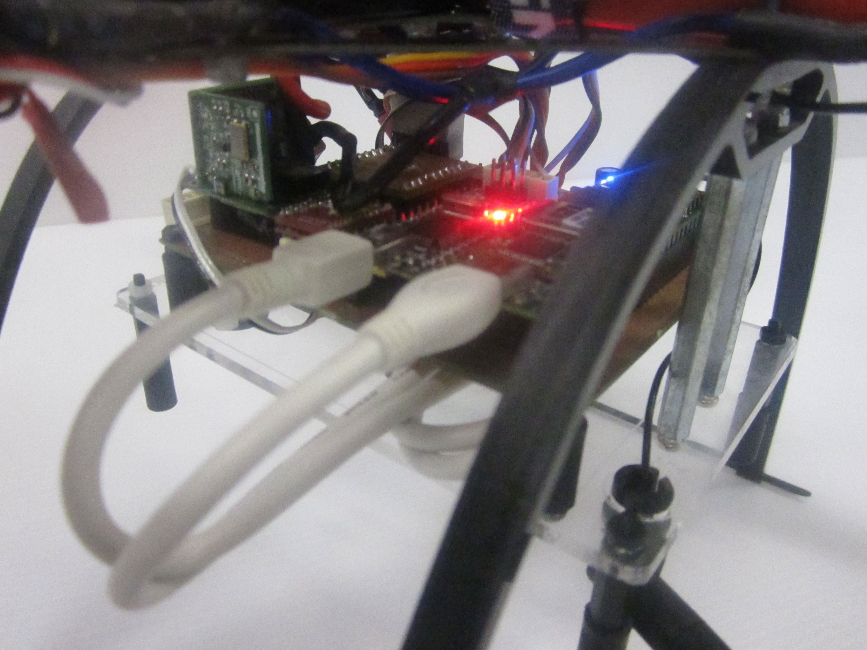

Figure – Final Design of Mounting System

The battery is mounted on top of the airframe, with enough clearance from the spinning propellers. The battery was connected with both Velcro straps, and Velcro dots underneath the battery. Figure 7 outlines the full configuration of the final mounting system design.

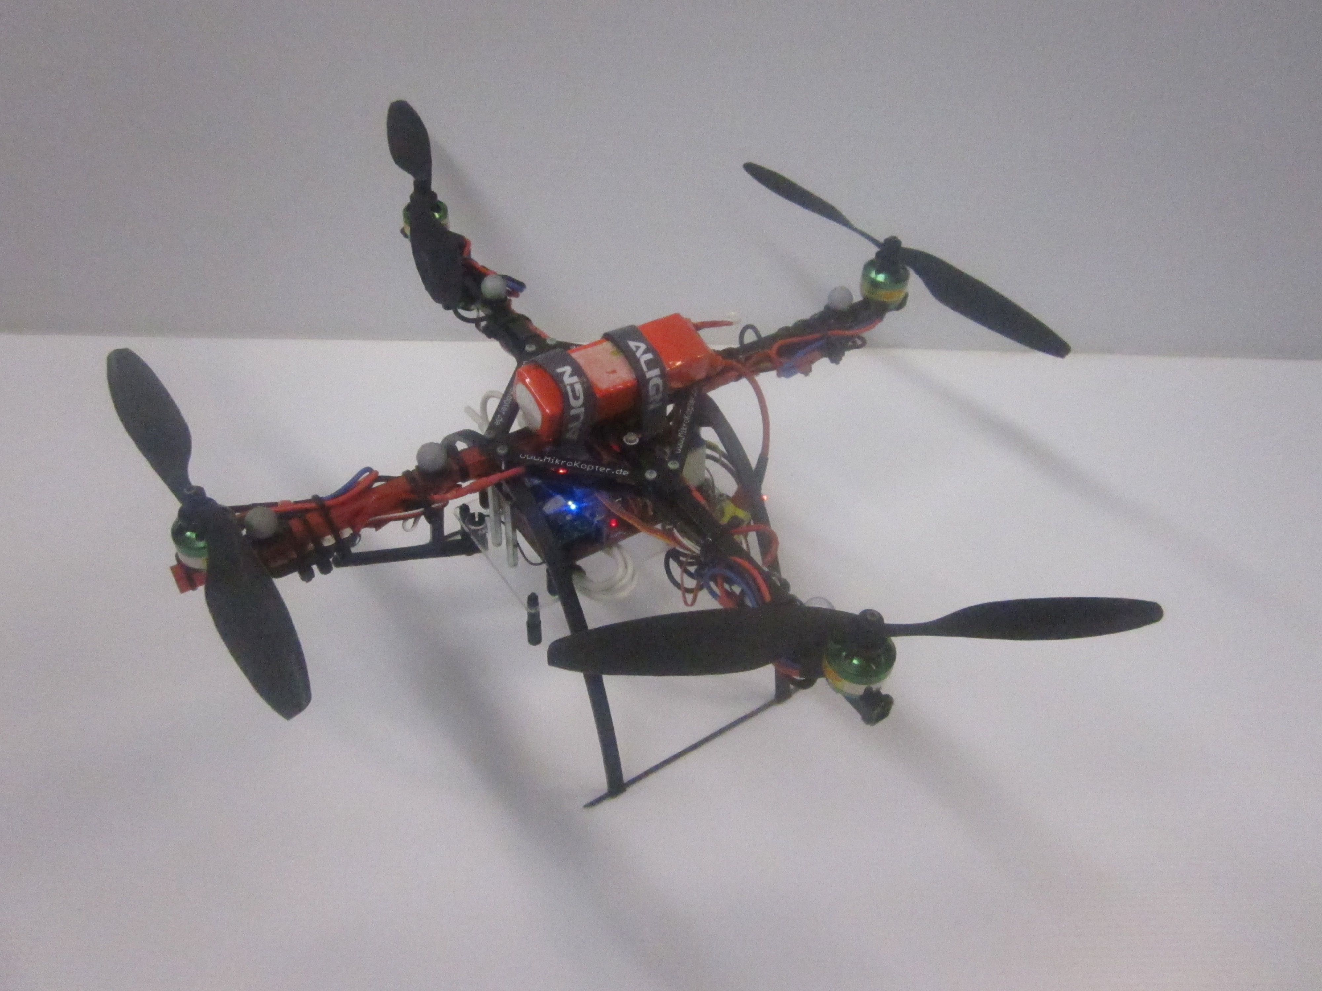

Figure – Battery Mounting for Final Design

# Conclusions

This document overviews the design process used in he construction of the hardware mounting system on the 2010 AHNS project. Due to design changes to the platform a second hardware mounting system had to be implemented which improved both overall weight and centre of mass position on the platform.

# Recommendations

It is recommended that the design drafted and implement is to be used during flight-testing over the semester. Additional acrylic platters should be made to replace broken components as a result from hard landings and crashes in flight testing. Testing should be taken with the current configuration to ensure that the mounting system can withstand manoeuvring while in flight.